

___________________________________________________________

**SCHOOL OF ENGINEERING AND TECHNOLOGY**

**FINAL ASSESSMENT FOR THE BSC (HONS) INFORMATION TECHNOLOGY; BSC (HONS) COMPUTER SCIENCE; YEAR 2**

**ACADEMIC SESSION 2022; SEMESTER 3**

**PRG2104: OBJECT ORIENTED PROGRAMMING**

**Project DEADLINE: Week 14**

**INSTRUCTIONS TO CANDIDATES**

# 

# This assignment will contribute 50% to your final grade.

* This is an individual assignment.

**IMPORTANT**

# The University requires students to adhere to submission deadlines for any form of assessment. Penalties are applied in relation to unauthorized late submission of work.

# Coursework submitted after the deadline will be awarded 0 marks

# 

**Lecturer’s Remark** (Use additional sheet if required)

I Bryan Chang Fa Kan (Name) 20043253 std. ID received the assignment and read the comments..............................(22/7/2022)......... (Signature/date)



**Academic Honesty Acknowledgement**

“I Bryan Chang Fa Kan (student name). verify that this paper contains entirely my own work. I have not consulted with any outside person or materials other than what was specified (an interviewee, for example) in the assignment or the syllabus requirements. Further, I have not copied or inadvertently copied ideas, sentences, or paragraphs from another student. I realize the penalties *(refer to page 16, 5.5, Appendix 2, page 44 of the student handbook diploma and undergraduate programme)* for any kind of copying or collaboration on any assignment.”



….................................. (Student’s signature / Date)

Table of Contents

Introduction 3

Class Diagram 3

Program Features 4

Feature 1: User Input for Player Name 5

Feature 2: Dinosaur Selection 6

Feature 3: View Dinosaur Information and Perform Upgrades 7

Feature 4: Choose Game Mode 8

Feature 5: Battleground Logic (Player vs Computer) 8

Feature 6: Implementation and Logic of 4 Dinosaur Skills 10

Feature 7: Dialog Box 12

Feature 8: View Scoreboard 13

Feature 9: View Guide 14

Feature 10: Game Balancing 14

Personal Reflection 16

References 17

## Introduction

The proposed standalone GUI program that has been developed in this project is known as “Jurassic Park Game”. Jurassic Park Game is a single-player dinosaur battle game aimed to bring dinosaurs back to life from Jurassic Park to have a fight off with each other. The game is filled with different selections of dinosaurs to choose and battle. This game supports different game modes such as easy mode and hard mode. In each of the game modes, the player has to fight their way to victory with their selected dinosaur to battle with the enemy dinosaurs. As it is a single-player game, only input from one player is expected throughout the course of the gaming session to battle against the computer.

## Class Diagram

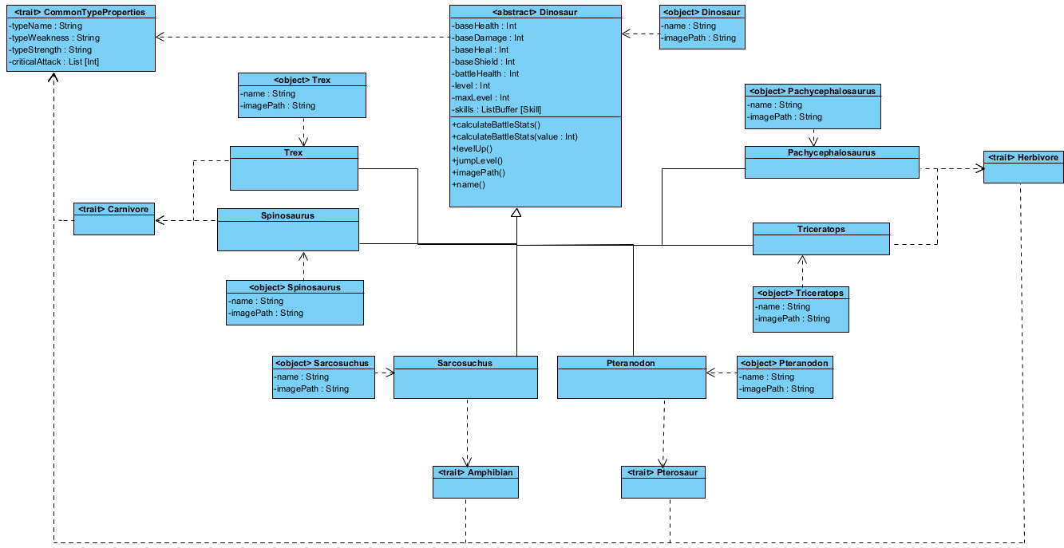

Class diagram of the abstract class Dinosaur inherited by 6 different classes of dinosaurs with their companion objects, the dinosaur types and common dinosaur type properties.

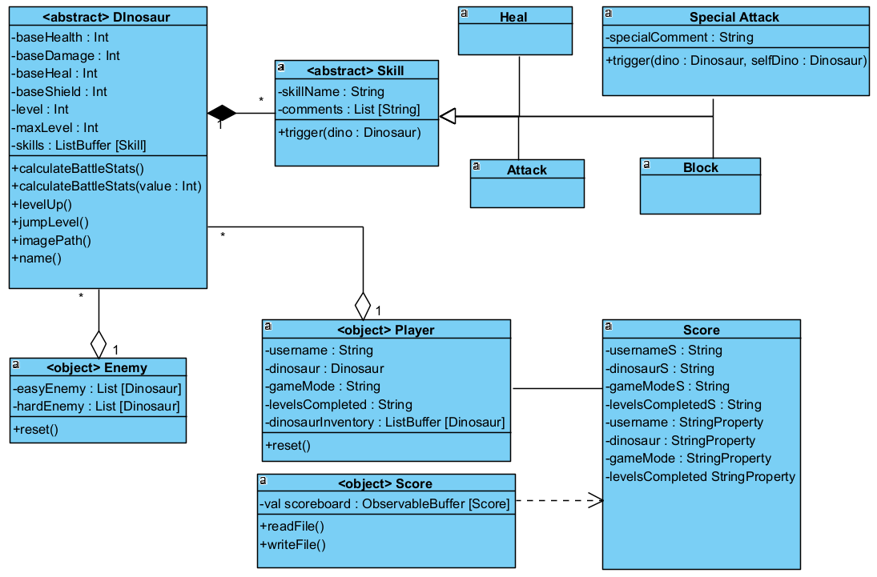

Class diagram of abstract class Dinosaur with abstract class Skill inherited by 4 different skills, Singleton object Player, Singleton object Enemy and Score class with its companion object.

## Program Features

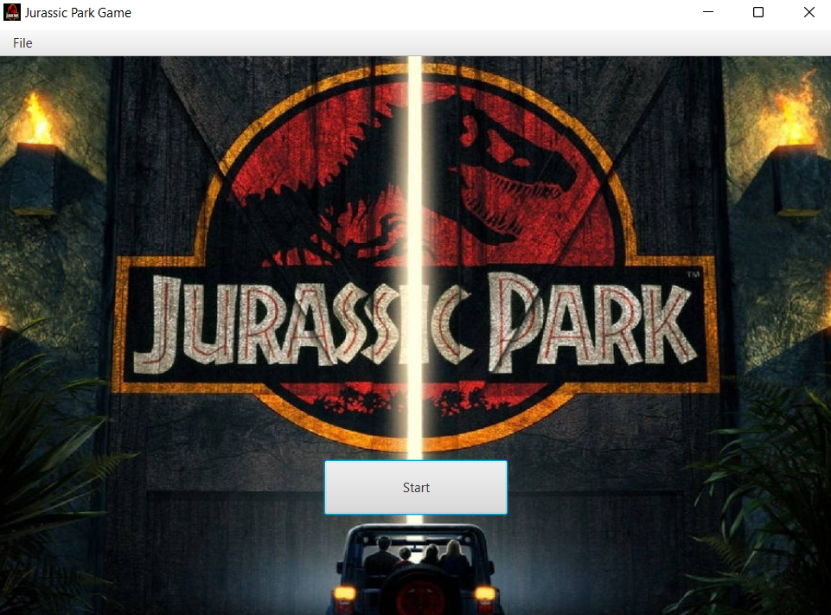

Figure Welcome Page

The Welcome page will display when starting the program.

### Feature 1: User Input for Player Name

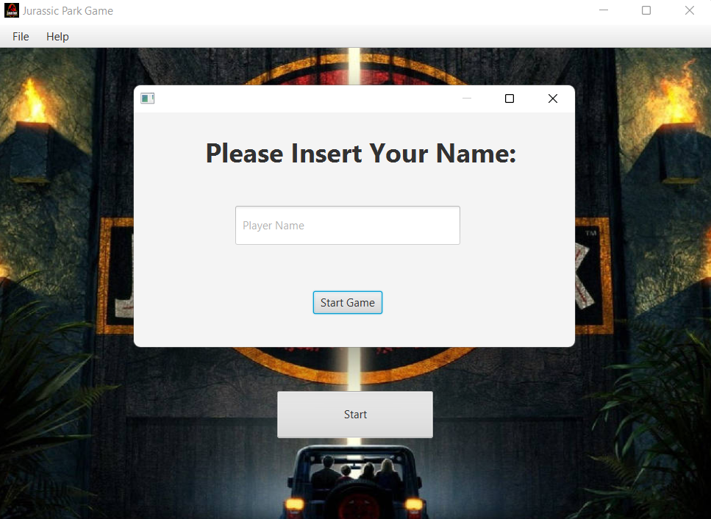

Figure Login pop-up

When “Start” button is clicked, a pop-up page will prompt the player to enter his/her name. Then, he/she must fill in the text field in order to proceed with the game. After that, the progress made by the player will be recorded together with the name they have inserted.

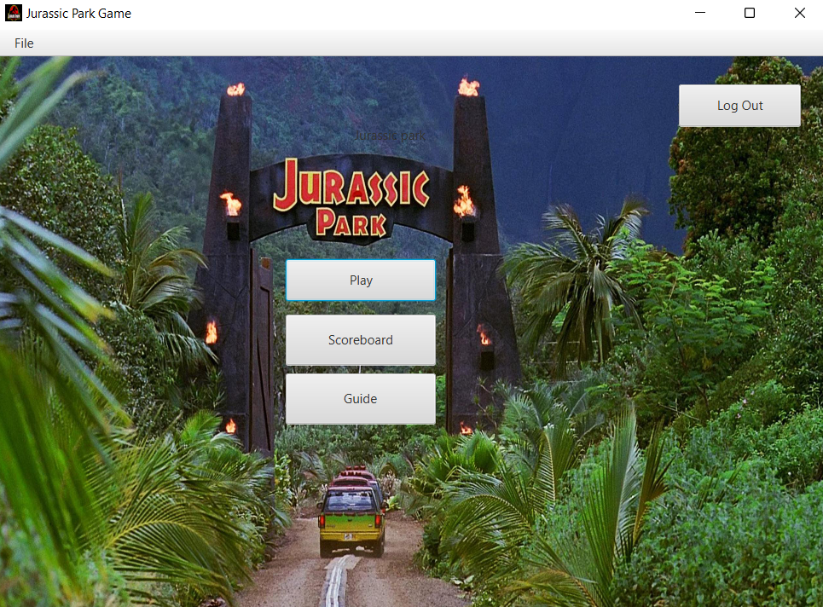

Figure Main Menu Page

This is the Main Menu page after the player has logged in to the Jurassic Park Game. The player will have the options to play the game, view the scoreboard or view the guide on how to play the game. There is also a log out button if the player wishes to log out, which will return the player back to the first page.

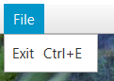

Figure MenuBar - Exit

The menu bar allows the player to easily exit the game. The exit menu item can be quickly accessed by using the shortcut key Ctrl+E to exit the game.

### Feature 2: Dinosaur Selection

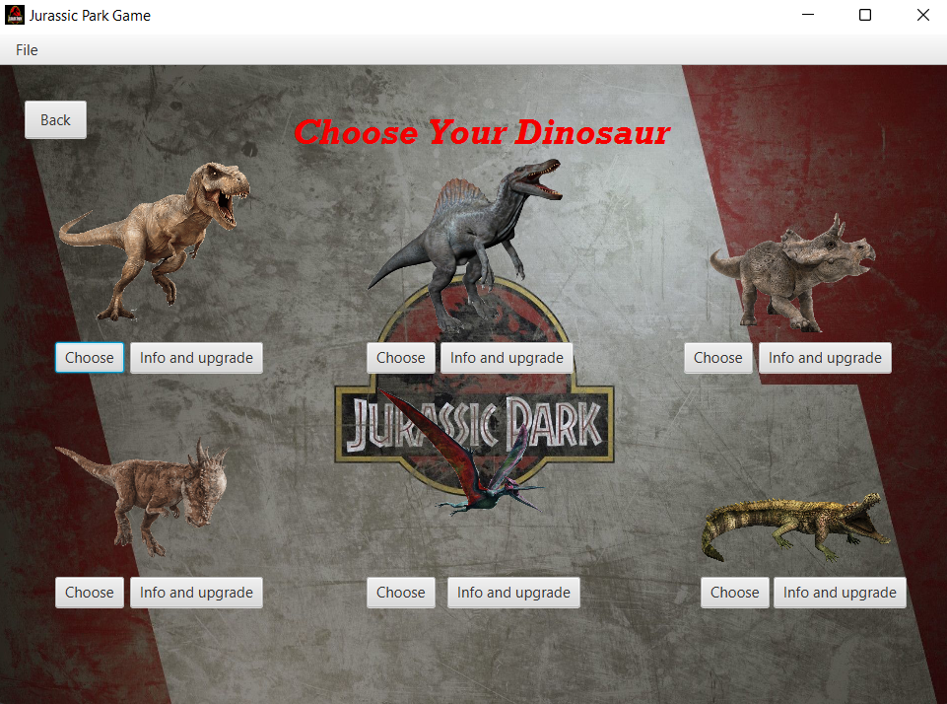

Figure 5 Dinosaur Selection Page

After the player clicked “Play” button, the player will be redirected to the dinosaur selection page. The player will have 6 dinosaur selections to choose from. Before choosing a dinosaur, the player can also view the information about the dinosaur and make upgrades to the dinosaur.

### Feature 3: View Dinosaur Information and Perform Upgrades

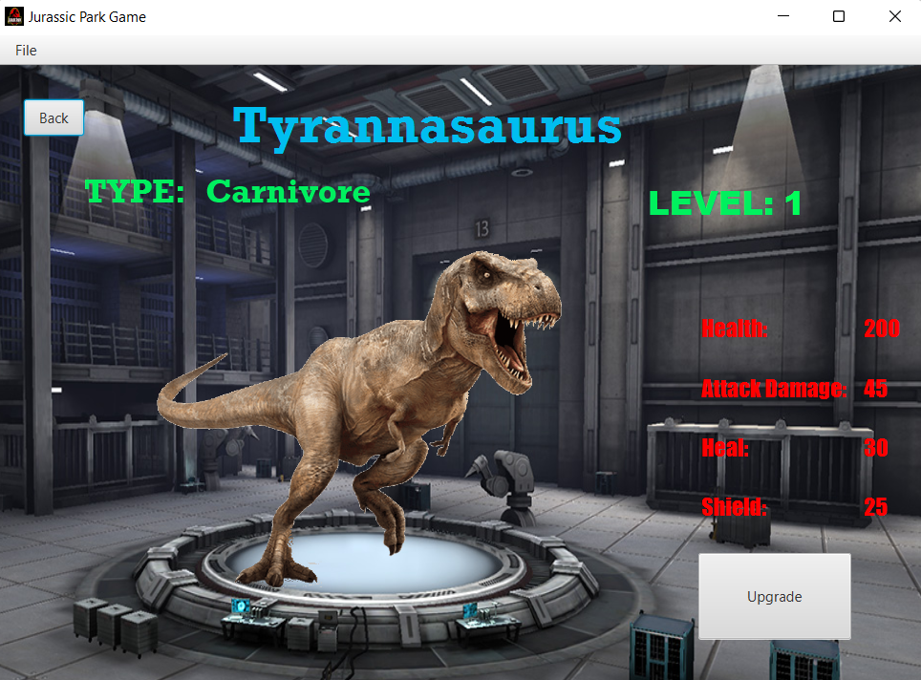

Figure 6 Info & Upgrade Page

After clicking “Info & Upgrade” button based on the dinosaur the player has clicked, the information related to the dinosaur will be displayed in this page. There is also an upgrade button to allow the player to upgrade the dinosaur’s stats such as increasing its health, attack damage, heal and shield. For every click of upgrade button, the dinosaur’s level will increase with its stats.

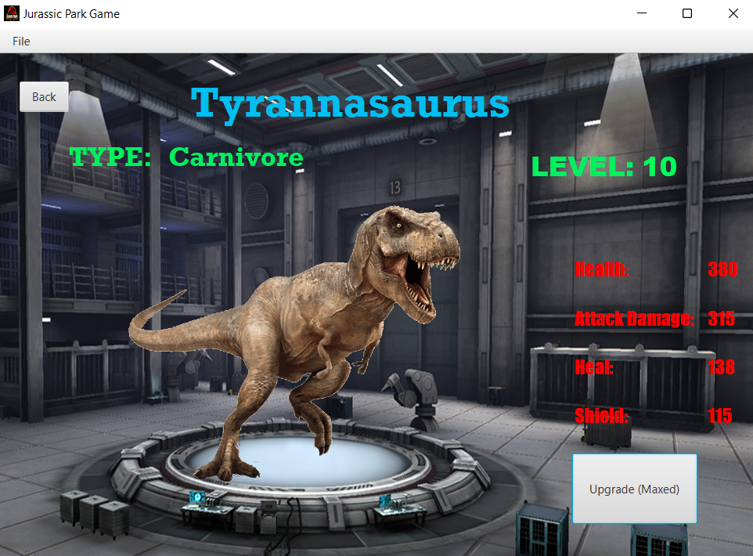

Figure 7 Info & Upgrade Page

Each of the dinosaurs are coded so that their max level is level 10. The max level can also be changed by setting maxLevel field in Dinosaur Class by the game developer if needed. Once level 10 is reached, the “Upgrade” button will change to “Upgrade (Maxed)” indicating max level is reached. The player can no longer increase the level and stats once max level is reached.

### Feature 4: Choose Game Mode

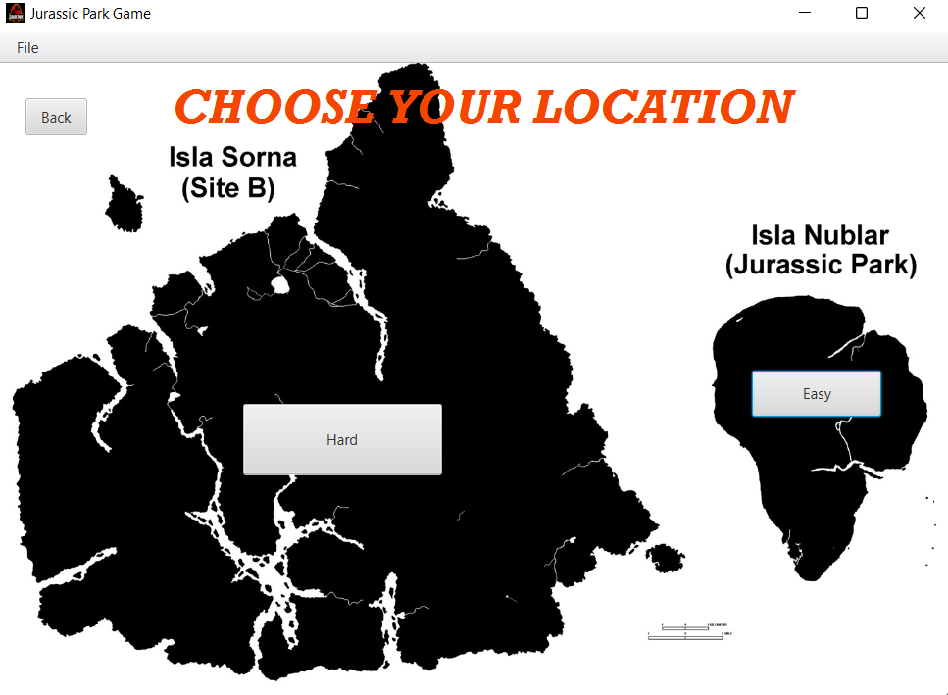

Figure 8 Map Page

In Dinosaur Selection page, after clicking the “Choose” button, the player will be directed to Map page. The player can choose their game mode based on the map, easy or hard mode.

### Feature 5: Battleground Logic (Player vs Computer)

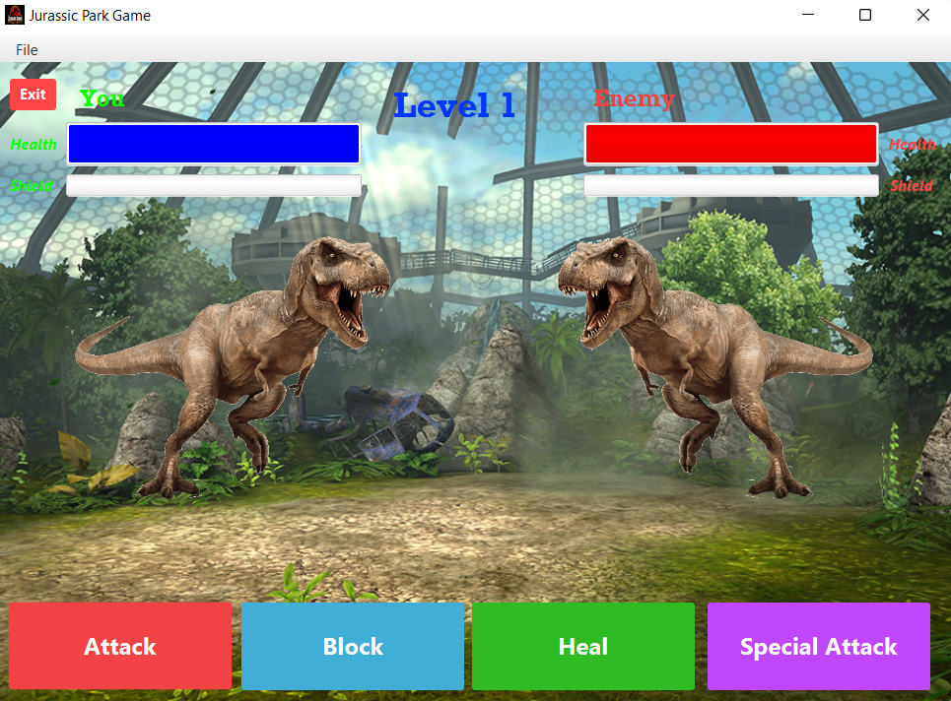

Figure 9 Battleground – Easy Mode Page

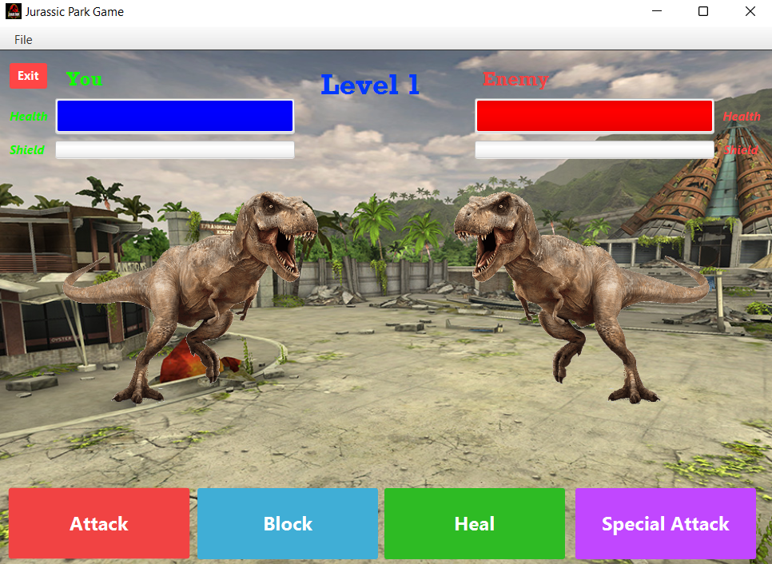

Figure 10 Battleground - Hard Mode Page

2 Different battlegrounds will be displayed based on whether the player chose the easy mode or the hard mode. As this is a single-player game, the player will fight against the enemy which is the computer. The player and the enemy will have their own health bar, shield bar, attack, block, heal and special attack. The dinosaur labelled with “You” on top is the player. The dinosaur labelled “Enemy” on top is the computer. The player will have to fight a total of 6 different enemy dinosaurs from game level 1 to level 6 in order to win the game.

As shown in the “Info & Upgrade page”, the player can upgrade the dinosaur. By using the same concept of levelling up in the enemy dinosaurs, the difference of easy and hard mode is the level of the enemy dinosaurs. All 6 dinosaurs in easy mode are set to level 1 whereas the 6 dinosaurs in hard mode are set to level 3.

The health bar shows the health of the dinosaur. The shield bar shows the shield that the dinosaur currently has. At the start of the game, the player and enemy dinosaur will have max health and no shield.

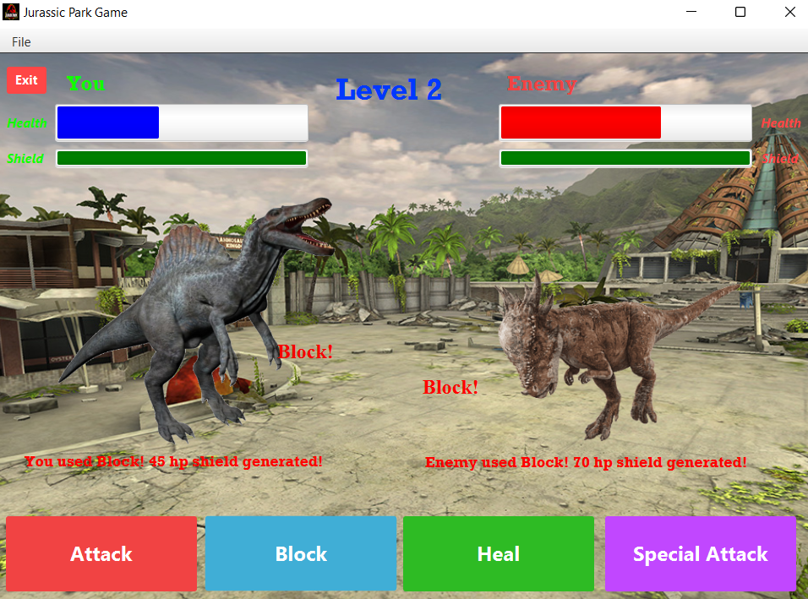

Figure 11 status of dinosaurs during a battle

### Feature 6: Implementation and Logic of 4 Dinosaur Skills

Each of the dinosaurs will have 4 skills, which are attack, block, heal and special attack. The “Attack” skill will deal damage to the opponent. For example, if the player uses the “Attack” skill, the enemy dinosaur health will decrease based on the damage taken from the player. The “Heal” skill adds health to the person that uses it. For example, if the player uses “Heal”, the player will be healed based on the heal value. The “Block” skill generates a shield to block off incoming damage from the opponent. The shield generated from using “Block” will be shown in the shield bar. A shield cannot be penetrated even though the shield’s health is lower than the attack damage from the opponent. The shield will absorb all the damage from the opponent. However, the shield can only be penetrated when using the “Special Attack” skill on opponent’s dinosaur that is your strength based on the dinosaur type. If opponent attack damage is higher than the shield, the remaining damage will be dealt to the victim’s health rather than absorbed by the shield if shield is penetrable.

The ultimate skill of the dinosaur is the “Special Attack”. The reason it is called a special attack is because special attack can benefit the person that is using only if it is used correctly. To understand how to use it effectively, the player must understand the class advantage of the dinosaur.

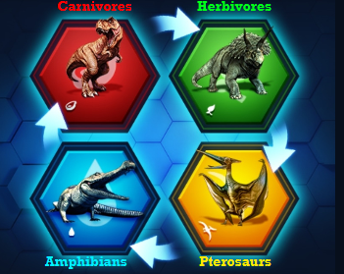

Figure 12 Class Advantage of Dinosaurs

Based on the class advantage, a dinosaur can be Carnivore, Herbivore, Pterosaur or Amphibian. The diagram shows the strengths and weaknesses in clockwise direction. The next dinosaur of the direction is the strength of the previous dinosaur, and the previous dinosaur of a dinosaur is the dinosaur’s weakness. For example, Carnivores have strength over Herbivore but Carnivores have weakness over Amphibians.

A special attack can deal reduced damage, critical damage or normal damage. The dinosaur will deal reduced damage if opponent is your weakness. The dinosaur will deal critical damage if the opponent is your strength and penetrates the shield. The dinosaur will deal normal damage, which is equivalent to the “Attack” skill if opponent is neither your weakness nor strength.

To calculate special attack, it takes the damage of “Attack” skill and add or deduct the additional damage based on special attack power value depending if the dinosaur is facing its strength or weakness. If neither weakness nor strength, it deals the same amount of damage as “Attack” skill.

When the 4 skills are used, there will be comments displayed to the screen, first comment showing the skills used by the user, the second comment showing the power value of the skill, and the third comment shows only when using special attack which indicates whether critical damage, normal damage or reduced damage is dealt to the enemy. Example as shown below:

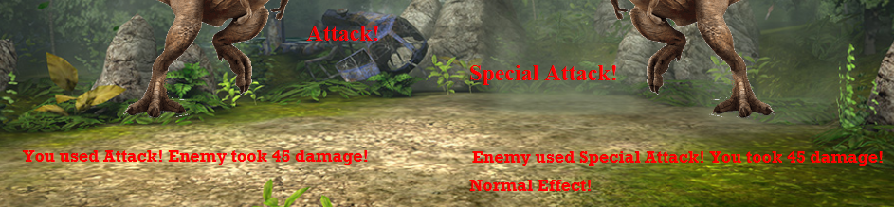

Figure 13 Comments

### Feature 7: Dialog Box

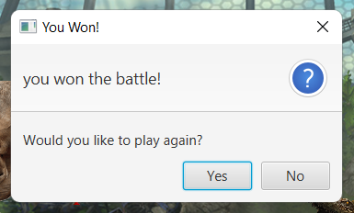

Figure 14 Win Dialog

When all 6 enemy dinosaurs are defeated, a win dialog will display. If press “Yes”, the player will be returned to the dinosaur selection page. If press “No”, the player will be redirected to the welcome page whereby the player is required to login again if he/she wishes to play. The player’s score will be recorded in the scoreboard.

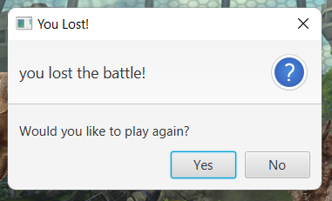

Figure 15 Lose Dialog

If the player dinosaur died and unable to defeat all 6 enemy dinosaurs, a lose dialog will display. If press “Yes”, the player will be returned to the dinosaur selection page. If press “No”, the player will be redirected to the welcome page whereby the player is required to login again if he/she wishes to play. The player’s score will be recorded in the scoreboard.

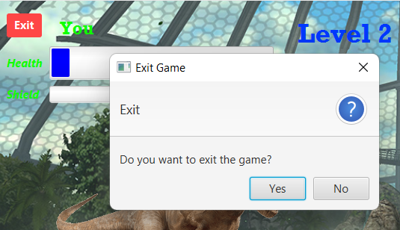

Figure 16 Exit Button

If the player decided to quit the current game and restart the game, the player can click the “Exit” button to do so. A confirmation dialog box will pop-up to reconfirm player’s decision to quit the current game. If press “Yes”, player will be returned to the dinosaur selection page. The player’s score will not be recorded in the scoreboard. If press “No”, the game continues.

### Feature 8: View Scoreboard

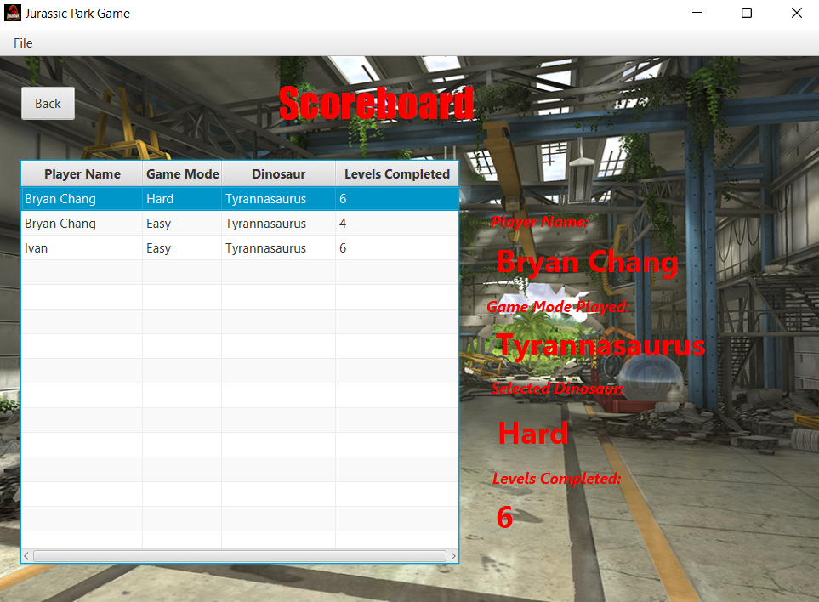

Figure 17 Scoreboard Page

The player can view their score in the Scoreboard page, which can be located after clicking the “Scoreboard” button in the Main Menu page. The scoreboard lists the history of games played by different players or same players by reading from a csv file and displaying it. After the end of each game, the game result will be recorded by the system and will be written into the csv file and displayed in the scoreboard.

### Feature 9: View Guide

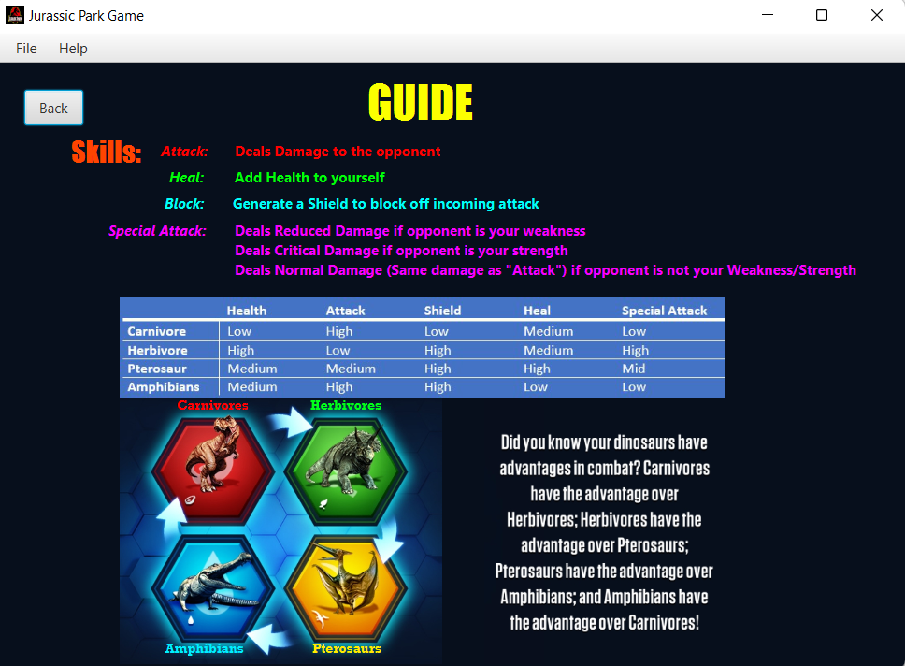

Figure 18 Guide Page

The player can look at the guide on how to play the game in the Guide Page, which can be located after clicking the “Guide” button in the Main Menu Page.

### Feature 10: Game Balancing

To make the game more fun and enjoyable, each dinosaur type of the dinosaurs will be given different power value of health, attack, shield, heal and special attack. Depending on the playstyle of a player, he/she may opt for different power value. This gives each dinosaur a unique set of power value so that all dinosaurs are distinct from each other giving different experiences to the user when using different dinosaurs.

Other than that, it also ensures that there is a balance between all the dinosaurs in the game. It is a design concept where strengths of a dinosaur are offset by a proportional drawback of the dinosaur to prevent domination of one dinosaur over other dinosaurs. In other words, ensuring that no dinosaurs are too overpowered. Although the proposed design is not perfect, but it shows the fundamental of the design applied to Jurassic Park Game as shown below:

Table created based on dinosaur types to determine their power value:

|  |  |  |  |  |  |
| --- | --- | --- | --- | --- | --- |
|  | Health | Attack | Shield | Heal | Special Attack |
| Carnivore | Low | High | Low | Medium | Low |
| Herbivore | High | Low | High | Medium | High |
| Pterosaur | Medium | Medium | High | High | Mid |
| Amphibian | Medium | High | High | Low | Low |

The power value for Low, Medium, High based on table above:

|  |  |  |  |  |  |
| --- | --- | --- | --- | --- | --- |
|  | Health | Attack | Shield | Heal | Special Attack |
| Low | 200 | 35 | 25 | 25 | 10,12,15,20 |
| Medium | 225 | 40 | 30 | 30 | 10,10,18,25 |
| High | 250 | 45 | 40 | 40 | 10,10,18,30 |

Increase of power value for each level upgrade:

|  |  |  |  |  |
| --- | --- | --- | --- | --- |
|  | Health | Shield | Attack | Heal |
| Low | 20 | 10 | 15 | 10 |
| Medium | 30 | 12 | 20 | 12 |
| High | 40 | 15 | 30 | 15 |

## Personal Reflection

In this assignment, I have applied several object-oriented concepts. Firstly, abstraction is applied in abstract class of Dinosaur and Skill as they are not meant to be instantiated but to show the functionality which will be implemented in the subclasses. Inheritance is shown when Trex class inherits the fields and methods of dinosaur abstract class while Attack class inherits the fields and methods of skill abstract class. Traits are also applied. Since Scala only supports single inheritance, traits are used to extend behaviour of the dinosaurs by extending dinosaur types such as Carnivore trait. Polymorphism is shown when calling the “trigger” method which produces different behaviour for different subclasses of skill although the method name is the same. Aggregation and composition are applied in scenario such as player has dinosaur, enemy has dinosaur, dinosaur has skill. As this game is a single-player game, player is made as a singleton object because the game only requires an instance of player to play. Enemy is also made as a singleton object to store lists of dinosaurs. Companion objects are used for storing common fields to all instances of a class such as dinosaur image path and dinosaur name.

One of the problems I have faced is calling a subclass method in a superclass type variable if the subclass method does not exist in the superclass. After consulting with Dr. Chin, I manage to solve this by using asInstanceOf to check the upcasted object and downcast it back to the subclass then call the method. As I am also unfamiliar with the MVC approach, I do not have any directions of where and how to start developing my program. Fortunately, I can refer to the Address App taught in the tutorial class which has given me a rough idea of how I should structure and code my program to follow the MVC design pattern.

One of the strengths is the simplicity and visual of the game interface. The player can easily navigate around the pages with visual aids in the interfaces. The program also follows an intuitive and consistent design. For instance, the “Back” button is placed on top left of the pages consistently and as expected. The game is designed to promote easy expandability in the future. For example, the current game modes, easy and hard mode can easily be expanded to many different modes. To improve player retention, the game promotes competitiveness by implementing a scoreboard so that other players can compete to be at the top.

In terms of the weaknesses, enemy counter moves such as attack, heal, shield and special attack are selected based on randomization rather than complex algorithms to perform strategical and tactical counter moves towards the player’s move. The game also lacks immersive gaming experience due to lack of animation and sound during dinosaur battles.

## References

**ScalaFX:**

Chin, T.M. (2015). *JavaFX 8 Tutorial - Part 1: Scene Builder* [Word Document]. Department of Computing and Information Systems. Sunway University.

Chin, T.M. (2015). *JavaFX 8 Tutorial - Part 2: Model and TableView* [Word Document]. Department of Computing and Information Systems. Sunway University.

Chin, T.M. (2015). *ScalaFX 8 Tutorial - Part 3: Interacting with the User* [Word Document]. Department of Computing and Information Systems. Sunway University.

Chin, T.M. (2014). *scalaFX 8 Tutorial - Part 4: CSS Styling* [Word Document]. Department of Computing and Information Systems. Sunway University.

**Game Concept Inspired by:**

*Jurassic World: The game*. 2015. Android and IOS. Publisher: [Ludia](https://www.google.com/search?rlz=1C1UEAD_enMY970MY970&sxsrf=ALiCzsYtPjIPYKNco35k8iakRLFiHpX7Xw:1658637841961&q=Ludia&stick=H4sIAAAAAAAAAOPgE-LVT9c3NEyrSKlKNim0UOLSz9U3SMqwKDLM0VLJTrbSTy5L10_Ozy0oLUktii_LTEnNT0_MTbUqKE3KySzOSC1axMrqU5qSmbiDlXEXOxMHAwDpFKyHUwAAAA&sa=X&ved=2ahUKEwi18YW725D5AhXE1jgGHYYbB_IQmxMoAXoECG0QAw).

**Background images:**

Kam, A. (2018). *Jurassic World Alive* [Digital image]. Jurassic World Alive. <http://www.alexkam.com/gallery/jurassicworldalive/>

*Jurassic Park Desktop Wallpapers*. (n.d.). [Digital Image]. WallpaperBat. [https://wallpaperbat.com/jurassic-park-desktop-wallpapers#](https://wallpaperbat.com/jurassic-park-desktop-wallpapers)

**Others:**

Alexander, A. (2022, May 18). *Scala: How to write text files (PrintWriter, FileWriter, BufferedWriter, and File)*. Alvin Alexander. https://alvinalexander.com/scala/how-to-write-text-files-in-scala-printwriter-filewriter/

Alexander, A. (2021, February 26). *How to cast a Scala object from one type to another (object casting)*. Alvin Alexander. <https://alvinalexander.com/scala/how-to-cast-objects-class-instance-in-scala-asinstanceof/>

GeeksforGeeks. (2019, February 27). *Scala | Traits*. <https://www.geeksforgeeks.org/scala-traits/#:%7E:text=In%20Scala%2C%20one%20trait%20can,by%20using%20a%20extends%20keyword.&text=Traits%20support%20multiple%20inheritance.,keyword%20before%20the%20trait’s%20name>.

Mohanty, S. (2021, June 2). *Scala Singleton and Companion objects and Advantages*. LinkedIn. https://www.linkedin.com/pulse/scala-singleton-companion-objects-advantages-swastik-mohanty/